Wholesaling process
Below is the end-to-end wholesaling process, explained cleanly from finding FSBO sellers → assigning to investors → closing. I’ll give you the mechanics, then the why behind each step so you can see where leverage, risk, and optimization live.

1. Marketing to FSBO & Distressed Home Sellers (Deal Sourcing)
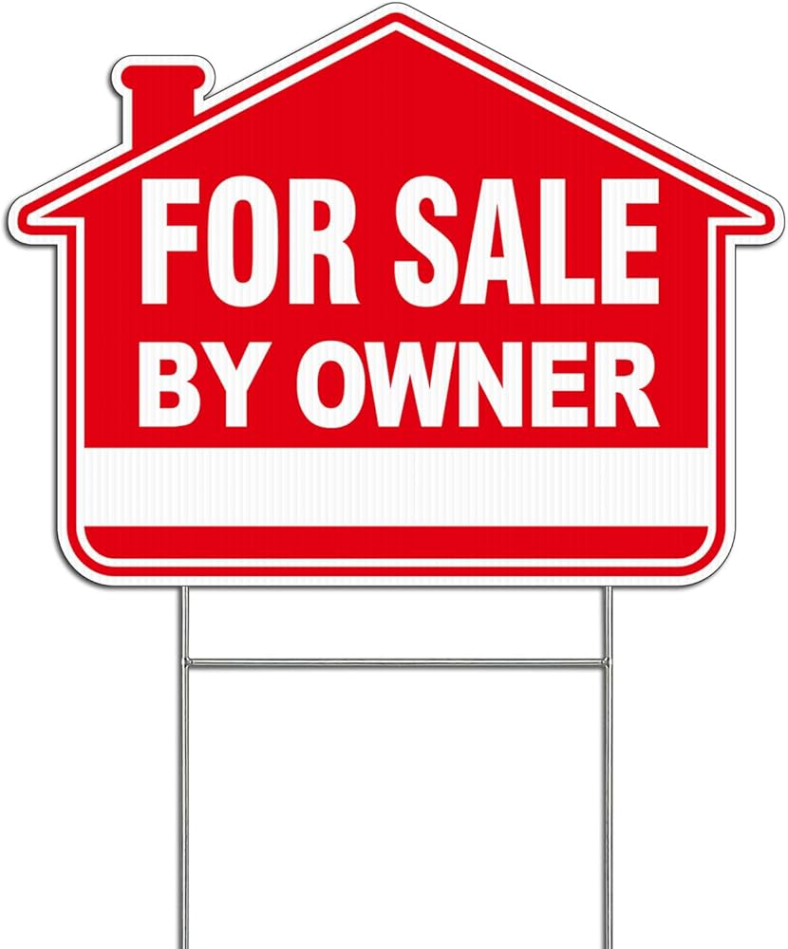

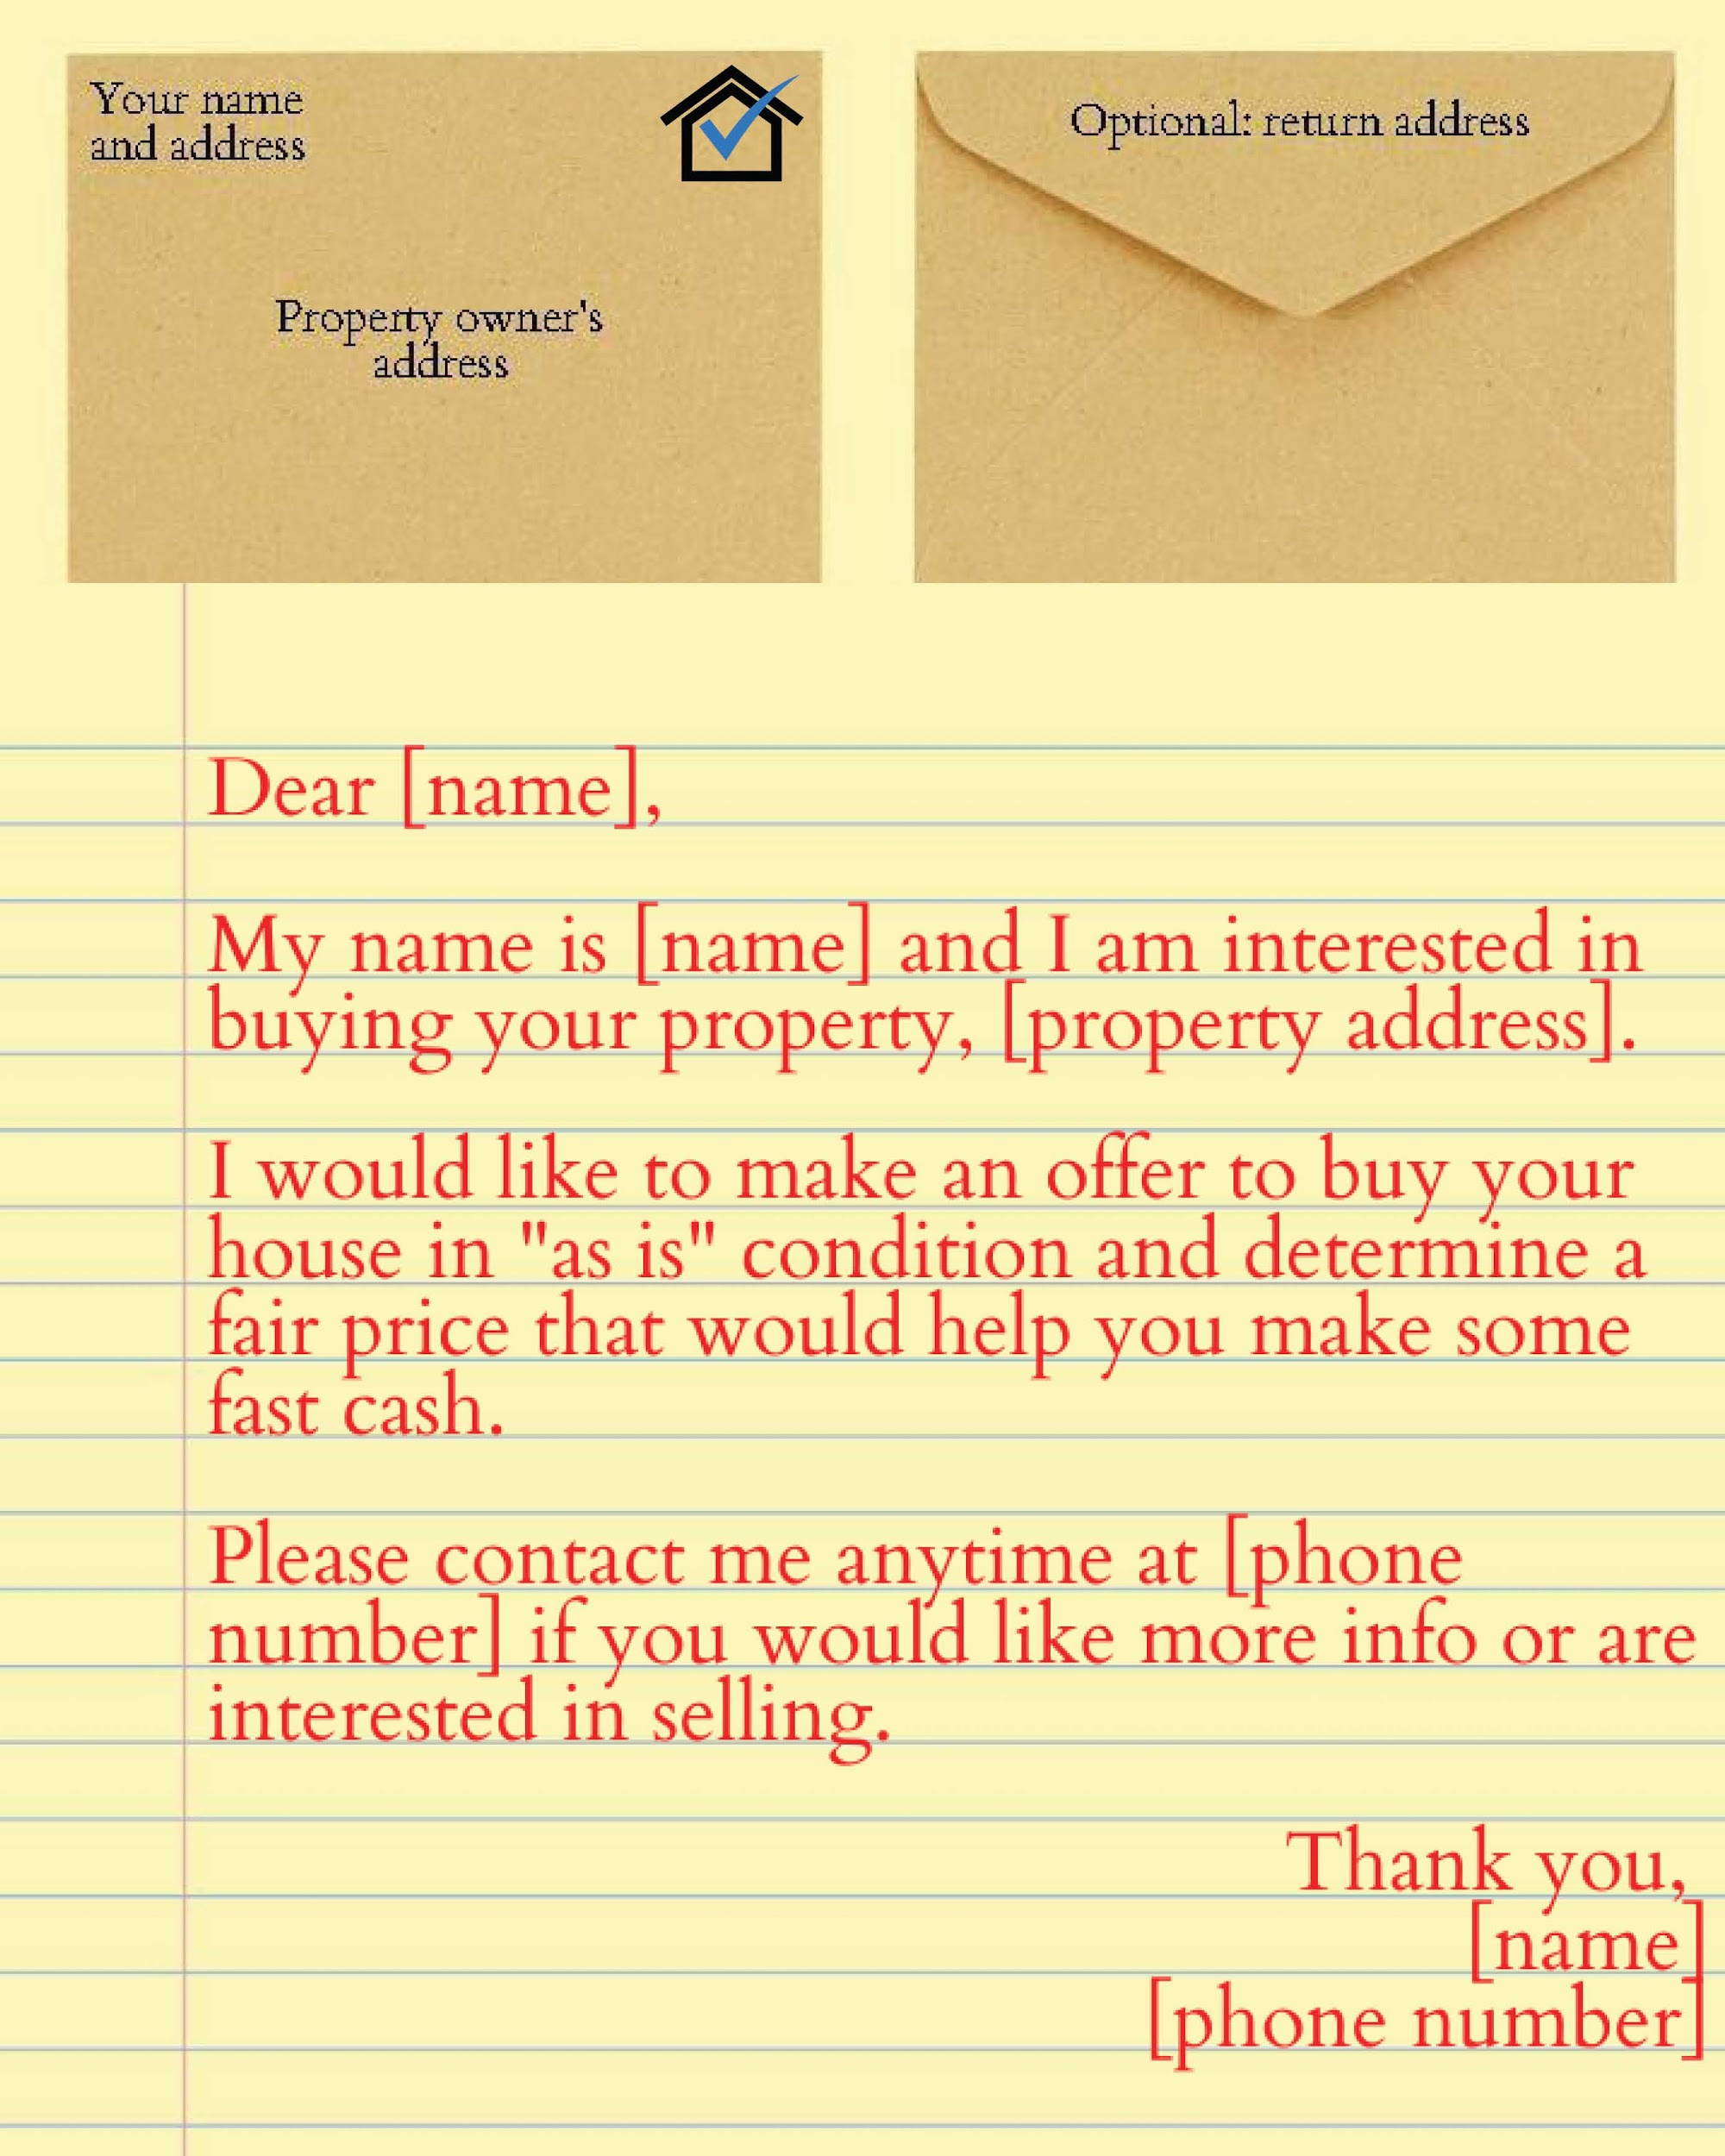
4

Goal
Create a pipeline of motivated sellers who care more about speed, certainty, or simplicity than top-dollar price.

Seller Types That Actually Convert
- FSBOs who don’t want agent fees
- Inherited / probate properties
- Landlords with tired tenants
- Code violations / deferred maintenance
- Divorce, relocation, or financial pressure

Common Seller Marketing Channels
Low cost / sweat equity
- Driving for dollars → texting/calling
- FSBO sites (Craigslist, Zillow FSBO)
- Facebook Marketplace & local groups
Scalable / paid
- Direct mail (handwritten-style letters)
- Cold calling lists (absentee, probate, tax delinquent)
- Google Local Services Ads (advanced)

Seller Conversation Framework (Very Important)
You are not pitching a price first. You’re diagnosing.
Key questions:
- “Why are you selling?”
- “What happens if you don’t sell?”
- “What condition is the property in?”
- “What’s your timeline?”
You’re qualifying motivation + flexibility, not just numbers.
Wholesalers don’t compete on price — they compete on certainty and ease.

2. Deal Analysis & Offer Structuring (Where Most Fail)
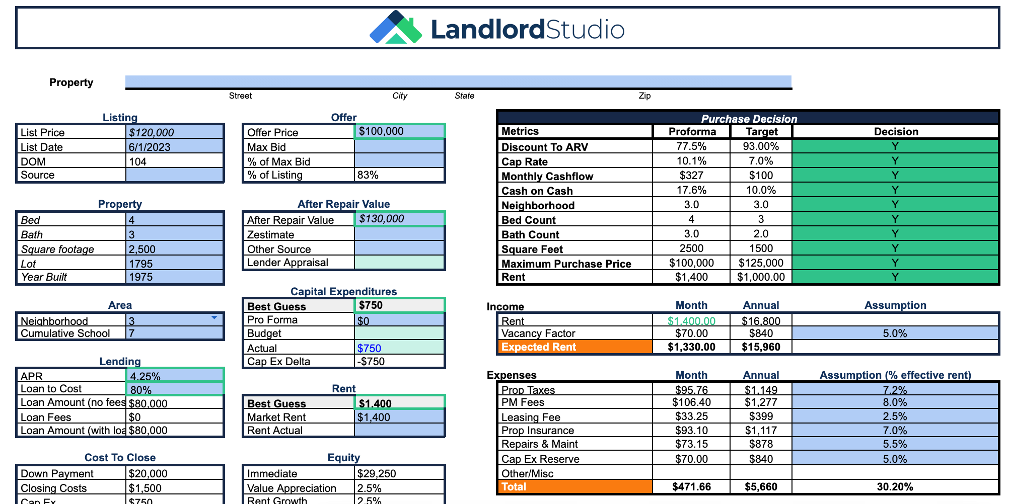
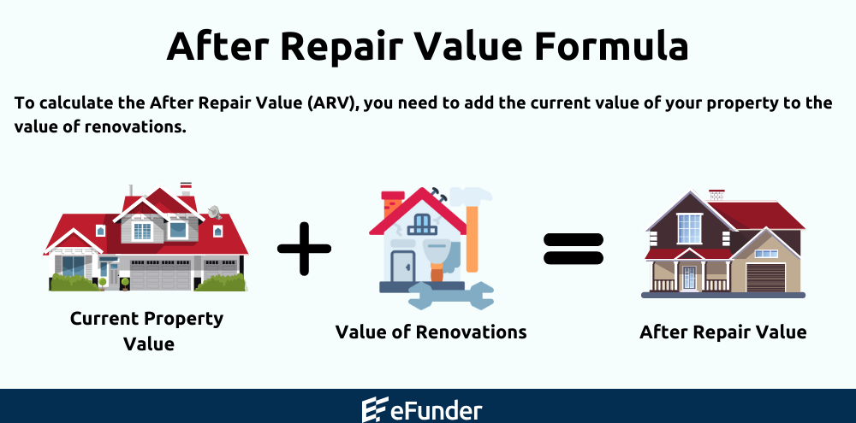
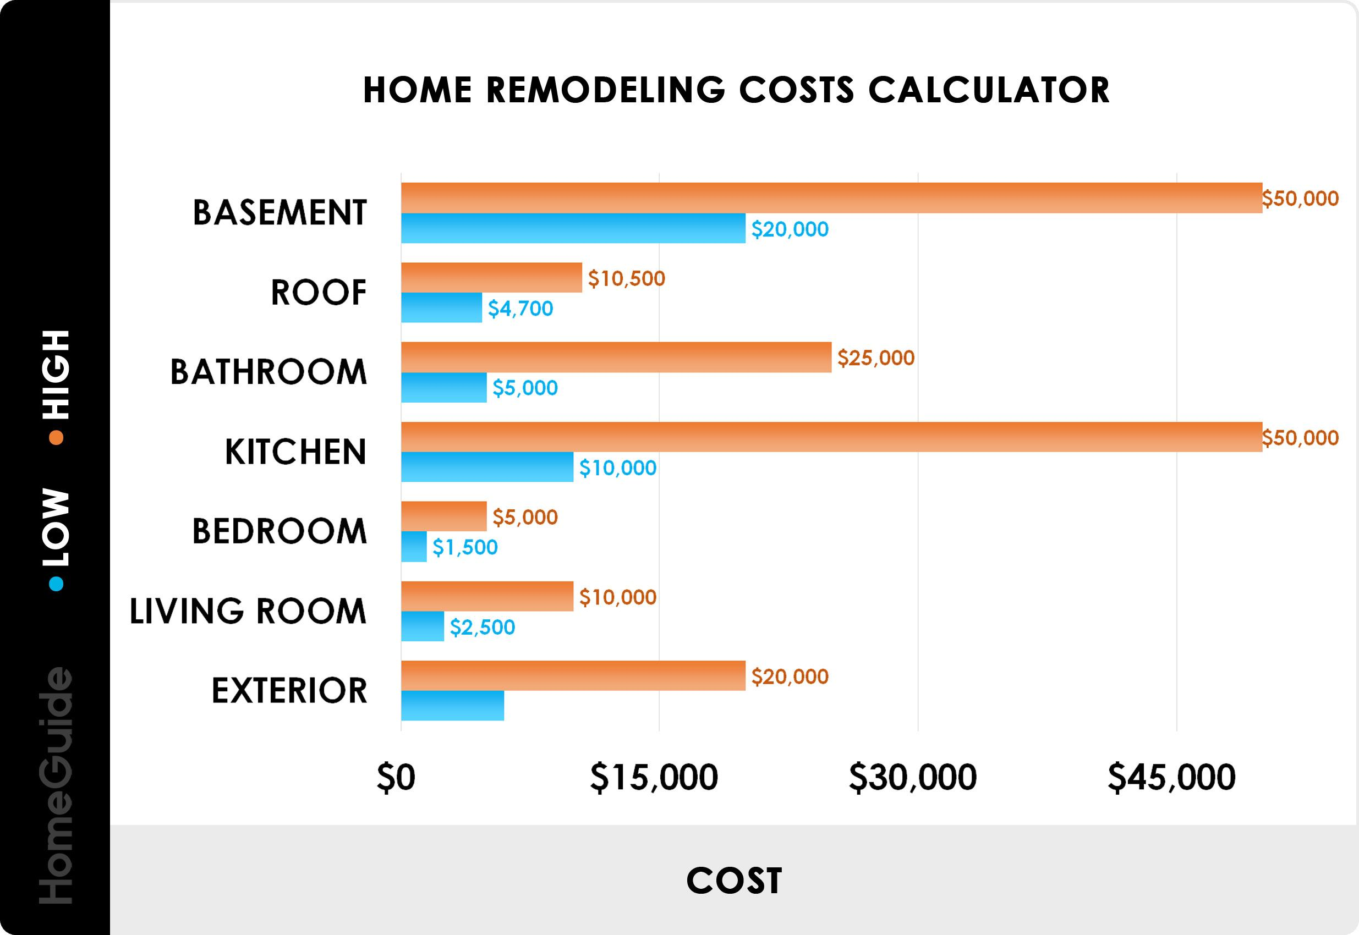
4

Core Formula (Industry Standard)
MAO = ARV × 70% − Repairs − Your Fee

Where:
- ARV = After Repair Value (based on comps)
- 70% rule = leaves room for investor profit + holding costs
- Your fee = $5k–$25k+ depending on market

Example
- ARV: $300,000
- Repairs: $40,000
- Investor MAO: $170,000
- You contract at: $155,000
- Your assignment fee: $15,000

Two Ways to Lock the Deal
- Assignment Contract (most common)
  - You never buy the house
  - You assign your rights to an end buyer
- Double Close
  - You close A→B and B→C same day
  - Used when seller or buyer must not see your fee

Contract Essentials
- Assignability clause
- Inspection / due diligence period
- Clear closing timeline
- Title & escrow selected early

3. Marketing to Cash Investors (Buyer Side)
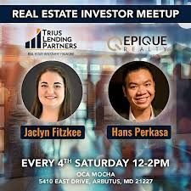
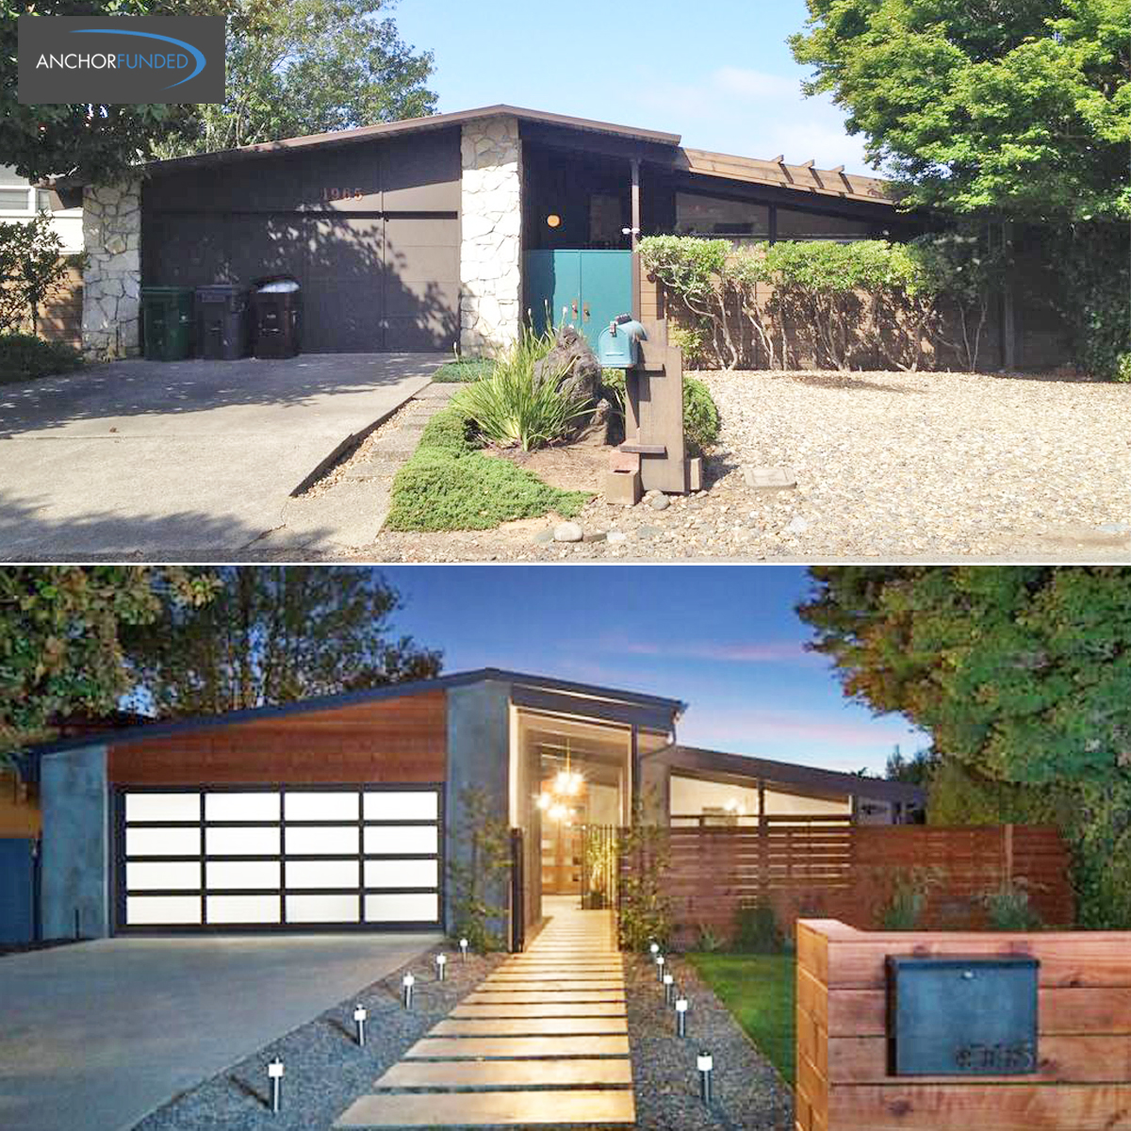
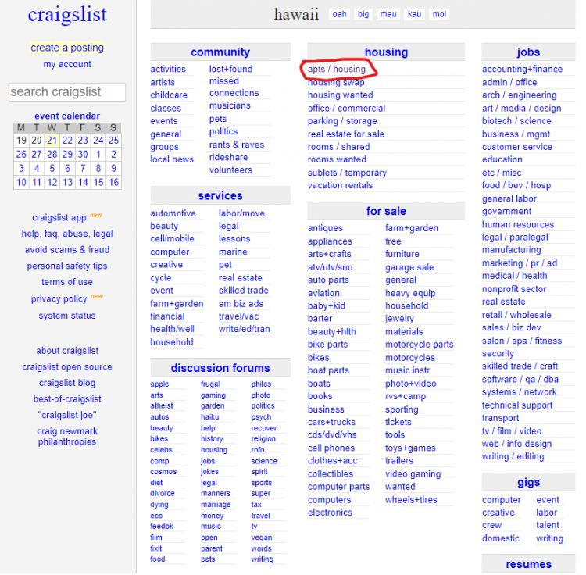
4

Goal
Sell speed and clarity, not hype.
Investors want:
- Clean numbers
- Accurate ARV
- Realistic repair estimate
- Clear exit (flip, rent, Airbnb)

Where Buyers Come From
- Your cash buyers list
- Facebook investor groups
- Local REI meetups
- Title company referrals
- Past deals (gold mine)

Deal Distribution Best Practice
You send a 1-page deal sheet:
- Address (or cross-street if sensitive)
- Price
- ARV + comps
- Repairs (line-item rough estimate)
- Access instructions
- Assignment fee included
Strong wholesalers pre-sell confidence, not properties.

Locking the Buyer
- Non-refundable earnest money
- Short inspection window
- Proof of funds (optional but powerful)

4. Due Diligence, Title, & Escrow
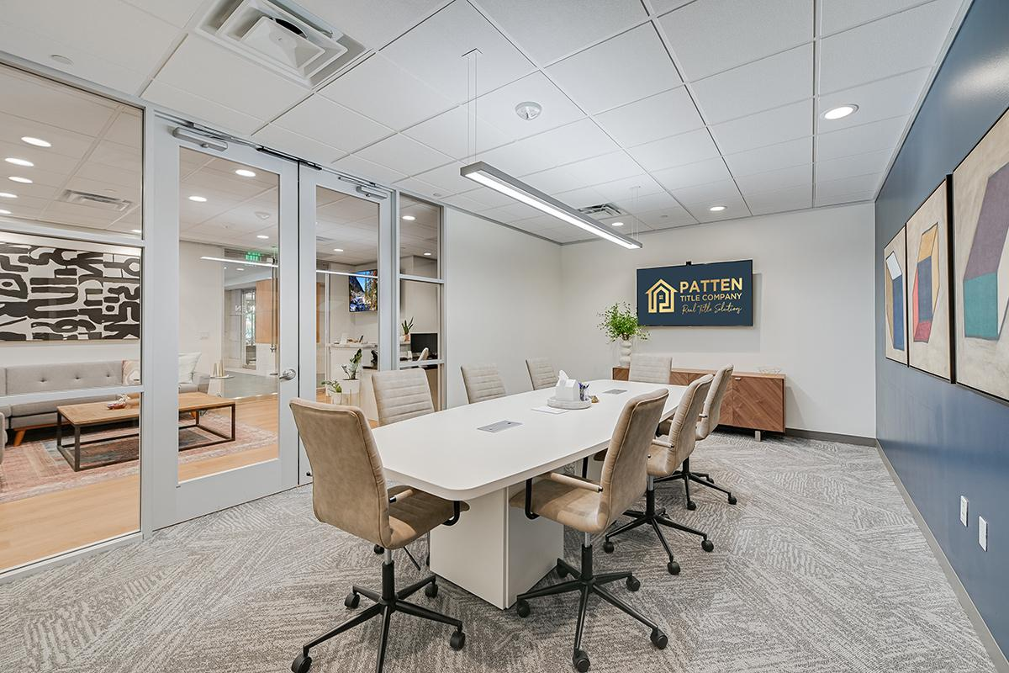
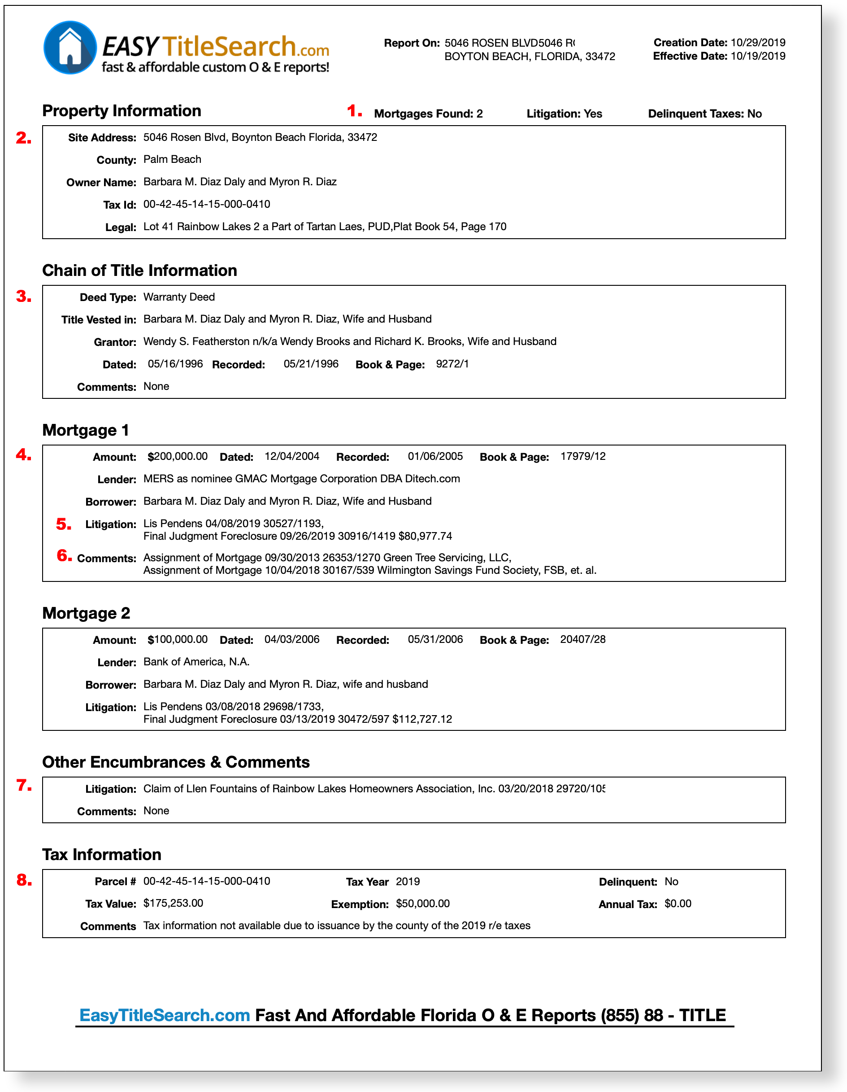
4

Title Work Begins
- Open escrow immediately after seller contract
- Title company checks:
  - Liens
  - Back taxes
  - Ownership issues
  - Probate or trust issues

Common Deal Killers
- Unreleased liens
- Heirs not disclosed
- Unrealistic ARV
- Repairs underestimated
- Seller changing mind
Great wholesalers solve problems, not avoid them.

5. Closing Day (Assignment or Double Close)

Assignment Close (Most Common)
- Buyer brings cash
- Seller gets agreed price
- You receive assignment fee from escrow
- No loan, fast funding (7–21 days typical)

Double Close
- Transaction A: Seller → You
- Transaction B: You → Buyer
- Often same-day using buyer’s funds
- Higher closing costs, higher privacy

6. Why Wholesaling Works (The Meta-Game)
Wholesaling is not “real estate investing.”
It is market-making.
You are:
- Creating liquidity for sellers who lack options
- Creating deal flow for investors who lack time
- Arbitraging speed, information, and certainty
The best wholesalers:
- Think like operators
- Track KPIs (leads → contracts → assignments)
- Build buyer relationships before sellers
- Protect reputation above short-term fees

7. The Invisible Skill (Most Important Insight)
Wholesaling success is emotional + operational mastery.
Sellers sell because of:
- Stress
- Uncertainty
- Life transitions
Buyers buy because of:
- Trust
- Predictability
- Repeated wins
If you want, next we can:
- Walk through a real example deal start to finish
- Build a simple wholesaling CRM flow
- Design a seller-to-buyer marketing funnel
- Or map how this integrates into a larger real estate enterprise
Just tell me where you want to go deeper.

